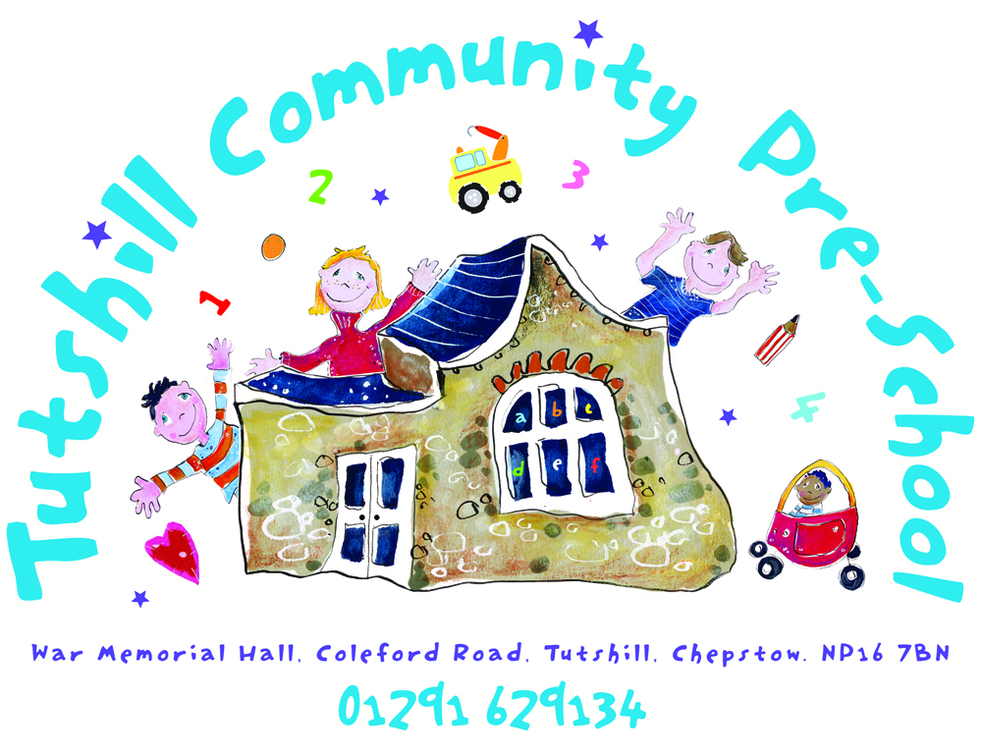
OFSTED No: - 101723
Charity No: - 1053927
Tutshill Nature Tots

To Parents and carers at Nature Tots

Before bringing your children to Nature Tots please read the Nature Tots risk assessment and follow these guidelines.
- You are fully responsible for the children you bring to Nature Tots at all times.
- Nature Tots is most suitable for children from 12 months to 5 years and we suggest that you bring a maximum of 3 children to look after during the session. (Please discuss this with the group leader before the session if you need to alter this number; siblings under 1 year can attend and will not be charged an entry fee.) You are of course welcome to attend if your baby is under 12 months and you will be charged £3.50.
- The entry fee for children is £3.50 for a session and their siblings over the age of 12 months will be £1.00. Please pay on the day with cash.
- We will be outside in all weathers so please dress your children and yourself carefully to protect yourselves from the elements, including sun hats and sun cream. Please bring a suitable face covering for yourself in case it is needed.
- If possible, please bring your child by yourself to the group as we are limited to 30 adults at the group and want to open it up to as many families as possible.
- During the Covid-19 pandemic we are sorry but will not be able to provide drinks or snacks for adults or children. Please bring drinks and snacks for your child as this is an active outside group.
- The sessions will be led by a member of Pre School staff trained in Early Years. They will bring play ideas and nature activities which can act as a springboard for the children to develop their own play.
We will enjoy singing (if less than 15 adults present), moving in different ways, exploring and may get wet and muddy. We may not make something each week to take home but the children will enjoy fresh air, and learn how to respect nature. The group leader will provide materials, resources and ideas of nature based activities you can carry out with your child at Nature Tots. They are provided if you want to make use of them, however we understand that you may want to come chat to the other parents and carers, especially after our lockdown days, which of course we welcome too.
- The session is held on the Tutshill Recreation Area at the opposite end to the play equipment. Parking, toilets and nappy change area is available nearby at The War Memorial Hall Tutshill NP16 7BN.
- If you take any photos during the session, please ensure you only have your own child in the photo. The Nature Tots leader will take photos of the activities at Nature Tots, but no children will appear in these photos. They will be posted on the Nature Tots Facebook page to show what we have done in the session.
The session will run from 9.30-11am on Fridays in Gloucestershire term time. Please look at the Tutshill Nature Tots Facebook page for details each week and last minute updates about the session. The current guidelines allow us to have a limited number of adults (excluding the leader) attending Nature Tots and so in order to secure a place please mark ‘Going’ on the relevant Facebook event anything up to a week in advance of the session.
Extra guidance during the COVID 19 Pandemic You will sign to say you agree with the following information at the start of the Nature Tots session. If you have any questions about the Covid-19 arrangements please let me know before the session on the Tutshill Nature Tots Facebook page. thank you.
- I confirm that whilst my child is attending Nature Tots my household will adhere to the rules set out by the government of my residence (England or Wales) to minimise the spread of the virus (e.g. social distancing, stay at home etc).
- I confirm that if my child, myself or anyone in my household shows symptoms of the Covid-19 virus my child will not attend Nature Tots and will self-isolate in accordance with government guidelines.
- If I or my child have a fever of 37.8 or above or a new persistent cough, I understand that we will not be able to attend Nature Tots on that day.
- I agree to engage with NHS Test and Trace where applicable, in line with Government Guidelines and the Nature Tots NHS Track andTrace explicit permission form. I agree to Tutshill Community Pre-School keeping my contact details for a period of time after I last attended Nature Tots for the purpose of Track and Trace.
- I agree to inform The NHS track and trace system and Nature Tots using the Tutshill Nature Tots Facebook page if I or members of my household test positive for Covid-19 in the week after attending Nature Tots.
- I agree to abide by rules put in place at Nature Tots to keep me, my child and the group leader safe. This includes staying at least 2 metres away from other adults at Nature Tots, wearing a suitable face mask and not joining in the singing.
- I agree that I will be asked to use antibacterial gel on my own and my child’s hands before and after the session and as necessary during the session.
- The group leader will have anti bacterial spray to use on frequently touched surfaces.
- I agree to maintain good hand hygiene after blowing my nose or helping clean my child’s face by remembering ‘ catch it, bin it, kill it ‘.
As part of the Covid-19 safety measures the group leader and the children can sing outside, the group leader will use an appropriate face covering while singing.
- The group leader running the Nature Tots session takes a lateral flow test twice a week and follows the current Government’s advice during the Covid 19 pandemic.
Please let us know what you think of the group, we really will value your feedback as we aim to make the group as exciting and rewarding for the children as possible

Thank You
Melanie Walton Nature Tots Leader
Tutshill Community Pre School 01291 629134
Tutshill Nature Tots on Facebook
June 2021

